Regular expressions

Regular expressions are patterns used to match character combinations in strings. In JavaScript, regular expressions are also objects. These patterns are used with the [exec()](https://developer.mozilla.org/en-US/docs/Web/JavaScript/Reference/Global_Objects/RegExp/exec) and [test()](https://developer.mozilla.org/en-US/docs/Web/JavaScript/Reference/Global_Objects/RegExp/test) methods of [RegExp](https://developer.mozilla.org/en-US/docs/Web/JavaScript/Reference/Global_Objects/RegExp), and with the [match()](https://developer.mozilla.org/en-US/docs/Web/JavaScript/Reference/Global_Objects/String/match), [matchAll()](https://developer.mozilla.org/en-US/docs/Web/JavaScript/Reference/Global_Objects/String/matchAll), [replace()](https://developer.mozilla.org/en-US/docs/Web/JavaScript/Reference/Global_Objects/String/replace), [replaceAll()](https://developer.mozilla.org/en-US/docs/Web/JavaScript/Reference/Global_Objects/String/replaceAll), [search()](https://developer.mozilla.org/en-US/docs/Web/JavaScript/Reference/Global_Objects/String/search), and [split()](https://developer.mozilla.org/en-US/docs/Web/JavaScript/Reference/Global_Objects/String/split) methods of [String](https://developer.mozilla.org/en-US/docs/Web/JavaScript/Reference/Global_Objects/String). This chapter describes JavaScript regular expressions.

[**Creating a regular expression**](https://developer.mozilla.org/en-US/docs/Web/JavaScript/Guide/Regular_expressions#creating_a_regular_expression)

You construct a regular expression in one of two ways:

Using a regular expression literal, which consists of a pattern enclosed between slashes, as follows:

JS

const re = /ab+c/;

Regular expression literals provide compilation of the regular expression when the script is loaded. If the regular expression remains constant, using this can improve performance.

Or calling the constructor function of the [RegExp](https://developer.mozilla.org/en-US/docs/Web/JavaScript/Reference/Global_Objects/RegExp) object, as follows:

JS

const re = new RegExp("ab+c");

Using the constructor function provides runtime compilation of the regular expression. Use the constructor function when you know the regular expression pattern will be changing, or you don't know the pattern and are getting it from another source, such as user input.

[**Writing a regular expression pattern**](https://developer.mozilla.org/en-US/docs/Web/JavaScript/Guide/Regular_expressions#writing_a_regular_expression_pattern)

A regular expression pattern is composed of simple characters, such as /abc/, or a combination of simple and special characters, such as /ab*c/ or /Chapter (\d+)\.\d*/. The last example includes parentheses, which are used as a memory device. The match made with this part of the pattern is remembered for later use, as described in [Using groups](https://developer.mozilla.org/en-US/docs/Web/JavaScript/Guide/Regular_expressions/Groups_and_backreferences#using_groups).

**Note:** If you are already familiar with the forms of a regular expression, you may also read [the cheat sheet](https://developer.mozilla.org/en-US/docs/Web/JavaScript/Guide/Regular_expressions/Cheatsheet) for a quick lookup for a specific pattern/construct.

[**Using simple patterns**](https://developer.mozilla.org/en-US/docs/Web/JavaScript/Guide/Regular_expressions#using_simple_patterns)

Simple patterns are constructed of characters for which you want to find a direct match. For example, the pattern /abc/ matches character combinations in strings only when the exact sequence "abc" occurs (all characters together and in that order). Such a match would succeed in the strings "Hi, do you know your abc's?" and "The latest airplane designs evolved from slabcraft.". In both cases the match is with the substring "abc". There is no match in the string "Grab crab" because while it contains the substring "ab c", it does not contain the exact substring "abc".

[**Using special characters**](https://developer.mozilla.org/en-US/docs/Web/JavaScript/Guide/Regular_expressions#using_special_characters)

When the search for a match requires something more than a direct match, such as finding one or more b's, or finding white space, you can include special characters in the pattern. For example, to match *a single "a" followed by zero or more "b"s followed by "c"*, you'd use the pattern /ab*c/: the * after "b" means "0 or more occurrences of the preceding item." In the string "cbbabbbbcdebc", this pattern will match the substring "abbbbc".

The following pages provide lists of the different special characters that fit into each category, along with descriptions and examples.

[Assertions](https://developer.mozilla.org/en-US/docs/Web/JavaScript/Guide/Regular_expressions/Assertions)

Assertions include boundaries, which indicate the beginnings and endings of lines and words, and other patterns indicating in some way that a match is possible (including look-ahead, look-behind, and conditional expressions).

[Character classes](https://developer.mozilla.org/en-US/docs/Web/JavaScript/Guide/Regular_expressions/Character_classes)

Distinguish different types of characters. For example, distinguishing between letters and digits.

[Groups and backreferences](https://developer.mozilla.org/en-US/docs/Web/JavaScript/Guide/Regular_expressions/Groups_and_backreferences)

Groups group multiple patterns as a whole, and capturing groups provide extra submatch information when using a regular expression pattern to match against a string. Backreferences refer to a previously captured group in the same regular expression.

[Quantifiers](https://developer.mozilla.org/en-US/docs/Web/JavaScript/Guide/Regular_expressions/Quantifiers)

Indicate numbers of characters or expressions to match.

If you want to look at all the special characters that can be used in regular expressions in a single table, see the following:

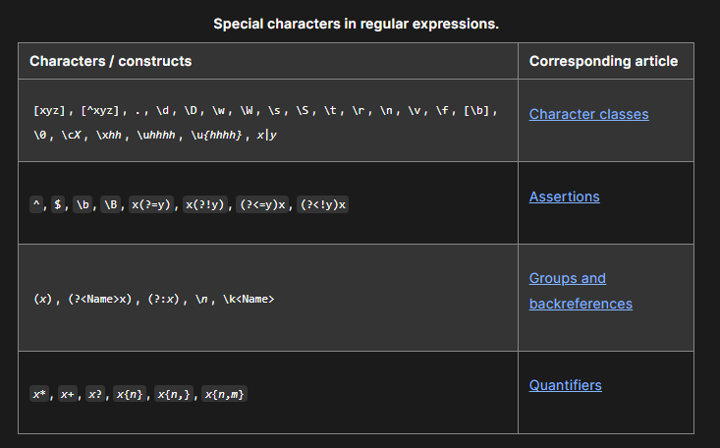

[**Escaping**](https://developer.mozilla.org/en-US/docs/Web/JavaScript/Guide/Regular_expressions#escaping)

If you need to use any of the special characters literally (actually searching for a "*", for instance), you must escape it by putting a backslash in front of it. For instance, to search for "a" followed by "*" followed by "b", you'd use /a\*b/ — the backslash "escapes" the "*", making it literal instead of special.

Similarly, if you're writing a regular expression literal and need to match a slash ("/"), you need to escape that (otherwise, it terminates the pattern). For instance, to search for the string "/example/" followed by one or more alphabetic characters, you'd use /\/example\/[a-z]+/i—the backslashes before each slash make them literal.

To match a literal backslash, you need to escape the backslash. For instance, to match the string "C:\" where "C" can be any letter, you'd use /[A-Z]:\\/ — the first backslash escapes the one after it, so the expression searches for a single literal backslash.

If using the RegExp constructor with a string literal, remember that the backslash is an escape in string literals, so to use it in the regular expression, you need to escape it at the string literal level. /a\*b/ and new RegExp("a\\*b") create the same expression, which searches for "a" followed by a literal "*" followed by "b".

If escape strings are not already part of your pattern you can add them using [String.prototype.replace()](https://developer.mozilla.org/en-US/docs/Web/JavaScript/Reference/Global_Objects/String/replace):

JS

function escapeRegExp(string) {

return string.replace(/[.*+?^${}()|[\]\\]/g, "\\$&"); // $& means the whole matched string

}

The "g" after the regular expression is an option or flag that performs a global search, looking in the whole string and returning all matches. It is explained in detail below in [Advanced Searching With Flags](https://developer.mozilla.org/en-US/docs/Web/JavaScript/Guide/Regular_expressions#advanced_searching_with_flags).

*Why isn't this built into JavaScript?* There is a [proposal](https://github.com/tc39/proposal-regex-escaping) to add such a function to RegExp.

[**Using parentheses**](https://developer.mozilla.org/en-US/docs/Web/JavaScript/Guide/Regular_expressions#using_parentheses)

Parentheses around any part of the regular expression pattern causes that part of the matched substring to be remembered. Once remembered, the substring can be recalled for other use. See [Groups and backreferences](https://developer.mozilla.org/en-US/docs/Web/JavaScript/Guide/Regular_expressions/Groups_and_backreferences#using_groups) for more details.

[**Using regular expressions in JavaScript**](https://developer.mozilla.org/en-US/docs/Web/JavaScript/Guide/Regular_expressions#using_regular_expressions_in_javascript)

Regular expressions are used with the [RegExp](https://developer.mozilla.org/en-US/docs/Web/JavaScript/Reference/Global_Objects/RegExp) methods [test()](https://developer.mozilla.org/en-US/docs/Web/JavaScript/Reference/Global_Objects/RegExp/test) and [exec()](https://developer.mozilla.org/en-US/docs/Web/JavaScript/Reference/Global_Objects/RegExp/exec) and with the [String](https://developer.mozilla.org/en-US/docs/Web/JavaScript/Reference/Global_Objects/String) methods [match()](https://developer.mozilla.org/en-US/docs/Web/JavaScript/Reference/Global_Objects/String/match), [replace()](https://developer.mozilla.org/en-US/docs/Web/JavaScript/Reference/Global_Objects/String/replace), [search()](https://developer.mozilla.org/en-US/docs/Web/JavaScript/Reference/Global_Objects/String/search), and [split()](https://developer.mozilla.org/en-US/docs/Web/JavaScript/Reference/Global_Objects/String/split).

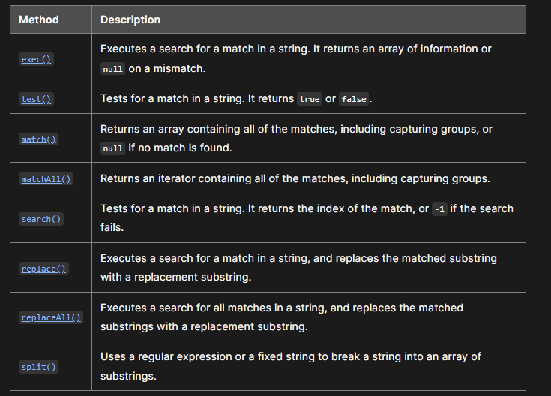

When you want to know whether a pattern is found in a string, use the test() or search() methods; for more information (but slower execution) use the exec() or match() methods. If you use exec() or match() and if the match succeeds, these methods return an array and update properties of the associated regular expression object and also of the predefined regular expression object, RegExp. If the match fails, the exec() method returns null (which coerces to false).

In the following example, the script uses the exec() method to find a match in a string.

JS

const myRe = /d(b+)d/g;

const myArray = myRe.exec("cdbbdbsbz");

If you do not need to access the properties of the regular expression, an alternative way of creating myArray is with this script:

JS

const myArray = /d(b+)d/g.exec("cdbbdbsbz");

// similar to 'cdbbdbsbz'.match(/d(b+)d/g); however,

// 'cdbbdbsbz'.match(/d(b+)d/g) outputs [ "dbbd" ]

// while /d(b+)d/g.exec('cdbbdbsbz') outputs [ 'dbbd', 'bb', index: 1, input: 'cdbbdbsbz' ]

(See [Using the global search flag with exec()](https://developer.mozilla.org/en-US/docs/Web/JavaScript/Guide/Regular_expressions#using_the_global_search_flag_with_exec) for further info about the different behaviors.)

If you want to construct the regular expression from a string, yet another alternative is this script:

JS

const myRe = new RegExp("d(b+)d", "g");

const myArray = myRe.exec("cdbbdbsbz");

With these scripts, the match succeeds and returns the array and updates the properties shown in the following table.

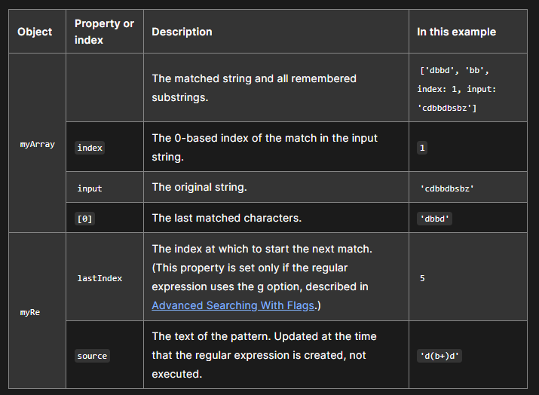

As shown in the second form of this example, you can use a regular expression created with an object initializer without assigning it to a variable. If you do, however, every occurrence is a new regular expression. For this reason, if you use this form without assigning it to a variable, you cannot subsequently access the properties of that regular expression. For example, assume you have this script:

JS

const myRe = /d(b+)d/g;

const myArray = myRe.exec("cdbbdbsbz");

console.log(`The value of lastIndex is ${myRe.lastIndex}`);

// "The value of lastIndex is 5"

However, if you have this script:

JS

const myArray = /d(b+)d/g.exec("cdbbdbsbz");

console.log(`The value of lastIndex is ${/d(b+)d/g.lastIndex}`);

// "The value of lastIndex is 0"

The occurrences of /d(b+)d/g in the two statements are different regular expression objects and hence have different values for their lastIndex property. If you need to access the properties of a regular expression created with an object initializer, you should first assign it to a variable.

[**Advanced searching with flags**](https://developer.mozilla.org/en-US/docs/Web/JavaScript/Guide/Regular_expressions#advanced_searching_with_flags)

Regular expressions have optional flags that allow for functionality like global searching and case-insensitive searching. These flags can be used separately or together in any order, and are included as part of the regular expression.

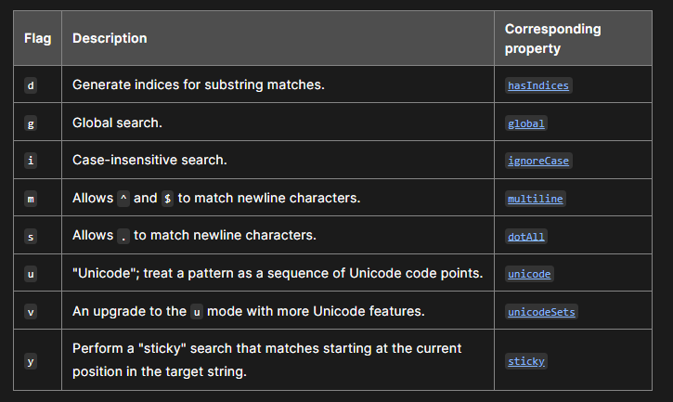

To include a flag with the regular expression, use this syntax:

JS

const re = /pattern/flags;

or

JS

const re = new RegExp("pattern", "flags");

Note that the flags are an integral part of a regular expression. They cannot be added or removed later.

For example, re = /\w+\s/g creates a regular expression that looks for one or more characters followed by a space, and it looks for this combination throughout the string.

JS

const re = /\w+\s/g;

const str = "fee fi fo fum";

const myArray = str.match(re);

console.log(myArray);

// ["fee ", "fi ", "fo "]

You could replace the line:

JS

const re = /\w+\s/g;

with:

JSCopy to Clipboard

const re = new RegExp("\\w+\\s", "g");

and get the same result.

The m flag is used to specify that a multiline input string should be treated as multiple lines. If the m flag is used, ^ and $ match at the start or end of any line within the input string instead of the start or end of the entire string.

**Using the global search flag with exec()**

[RegExp.prototype.exec()](https://developer.mozilla.org/en-US/docs/Web/JavaScript/Reference/Global_Objects/RegExp/exec) method with the g flag returns each match and its position iteratively.

JSCopy to Clipboard

const str = "fee fi fo fum";

const re = /\w+\s/g;

console.log(re.exec(str)); // ["fee ", index: 0, input: "fee fi fo fum"]

console.log(re.exec(str)); // ["fi ", index: 4, input: "fee fi fo fum"]

console.log(re.exec(str)); // ["fo ", index: 7, input: "fee fi fo fum"]

console.log(re.exec(str)); // null

In contrast, [String.prototype.match()](https://developer.mozilla.org/en-US/docs/Web/JavaScript/Reference/Global_Objects/String/match) method returns all matches at once, but without their position.

JS

console.log(str.match(re)); // ["fee ", "fi ", "fo "]

**Using unicode regular expressions**

The u flag is used to create "unicode" regular expressions; that is, regular expressions which support matching against unicode text. An important feature that's enabled in unicode mode is [Unicode property escapes](https://developer.mozilla.org/en-US/docs/Web/JavaScript/Reference/Regular_expressions/Unicode_character_class_escape). For example, the following regular expression might be used to match against an arbitrary unicode "word":

JS

/\p{L}*/u;

Unicode regular expressions have different execution behavior as well. [RegExp.prototype.unicode](https://developer.mozilla.org/en-US/docs/Web/JavaScript/Reference/Global_Objects/RegExp/unicode) contains more explanation about this.

[**Examples**](https://developer.mozilla.org/en-US/docs/Web/JavaScript/Guide/Regular_expressions#examples)

**Note:** Several examples are also available in:

* The reference pages for [exec()](https://developer.mozilla.org/en-US/docs/Web/JavaScript/Reference/Global_Objects/RegExp/exec), [test()](https://developer.mozilla.org/en-US/docs/Web/JavaScript/Reference/Global_Objects/RegExp/test), [match()](https://developer.mozilla.org/en-US/docs/Web/JavaScript/Reference/Global_Objects/String/match), [matchAll()](https://developer.mozilla.org/en-US/docs/Web/JavaScript/Reference/Global_Objects/String/matchAll), [search()](https://developer.mozilla.org/en-US/docs/Web/JavaScript/Reference/Global_Objects/String/search), [replace()](https://developer.mozilla.org/en-US/docs/Web/JavaScript/Reference/Global_Objects/String/replace), [split()](https://developer.mozilla.org/en-US/docs/Web/JavaScript/Reference/Global_Objects/String/split)
* The guide articles: [character classes](https://developer.mozilla.org/en-US/docs/Web/JavaScript/Guide/Regular_expressions/Character_classes), [assertions](https://developer.mozilla.org/en-US/docs/Web/JavaScript/Guide/Regular_expressions/Assertions), [groups and backreferences](https://developer.mozilla.org/en-US/docs/Web/JavaScript/Guide/Regular_expressions/Groups_and_backreferences), [quantifiers](https://developer.mozilla.org/en-US/docs/Web/JavaScript/Guide/Regular_expressions/Quantifiers)

[**Using special characters to verify input**](https://developer.mozilla.org/en-US/docs/Web/JavaScript/Guide/Regular_expressions#using_special_characters_to_verify_input)

In the following example, the user is expected to enter a phone number. When the user presses the "Check" button, the script checks the validity of the number. If the number is valid (matches the character sequence specified by the regular expression), the script shows a message thanking the user and confirming the number. If the number is invalid, the script informs the user that the phone number is not valid.

The regular expression looks for:

1. the beginning of the line of data: ^
2. followed by three numeric characters \d{3} OR | a left parenthesis \(, followed by three digits \d{3}, followed by a close parenthesis \), in a non-capturing group (?:)
3. followed by one dash, forward slash, or decimal point in a capturing group ()
4. followed by three digits \d{3}
5. followed by the match remembered in the (first) captured group \1
6. followed by four digits \d{4}
7. followed by the end of the line of data: $

**HTML**

<p>

Enter your phone number (with area code) and then click "Check".

<br />

The expected format is like ###-###-####.

</p>

<form id="form">

<input id="phone" />

<button type="submit">Check</button>

</form>

<p id="output"></p>

**JavaScript**

JS

const form = document.querySelector("#form");

const input = document.querySelector("#phone");

const output = document.querySelector("#output");

const re = /^(?:\d{3}|\(\d{3}\))([-/.])\d{3}\1\d{4}$/;

function testInfo(phoneInput) {

const ok = re.exec(phoneInput.value);

output.textContent = ok

? `Thanks, your phone number is ${ok[0]}`

: `${phoneInput.value} isn't a phone number with area code!`;

}

form.addEventListener("submit", (event) => {

event.preventDefault();

testInfo(input);

});

**Result**

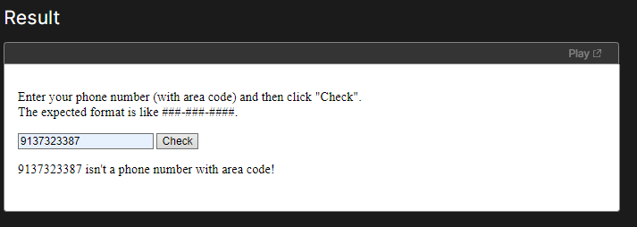

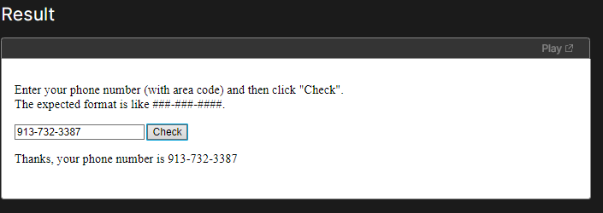

[**Tools**](https://developer.mozilla.org/en-US/docs/Web/JavaScript/Guide/Regular_expressions#tools)

[RegExr](https://regexr.com/)

An online tool to learn, build, & test Regular Expressions.

[Regex tester](https://regex101.com/)

An online regex builder/debugger

[Regex interactive tutorial](https://regexlearn.com/)

An online interactive tutorials, Cheat sheet, & Playground.

[Regex visualizer](https://extendsclass.com/regex-tester.html)

An online visual regex tester.